Exercise 1 - Prepare the lab environment

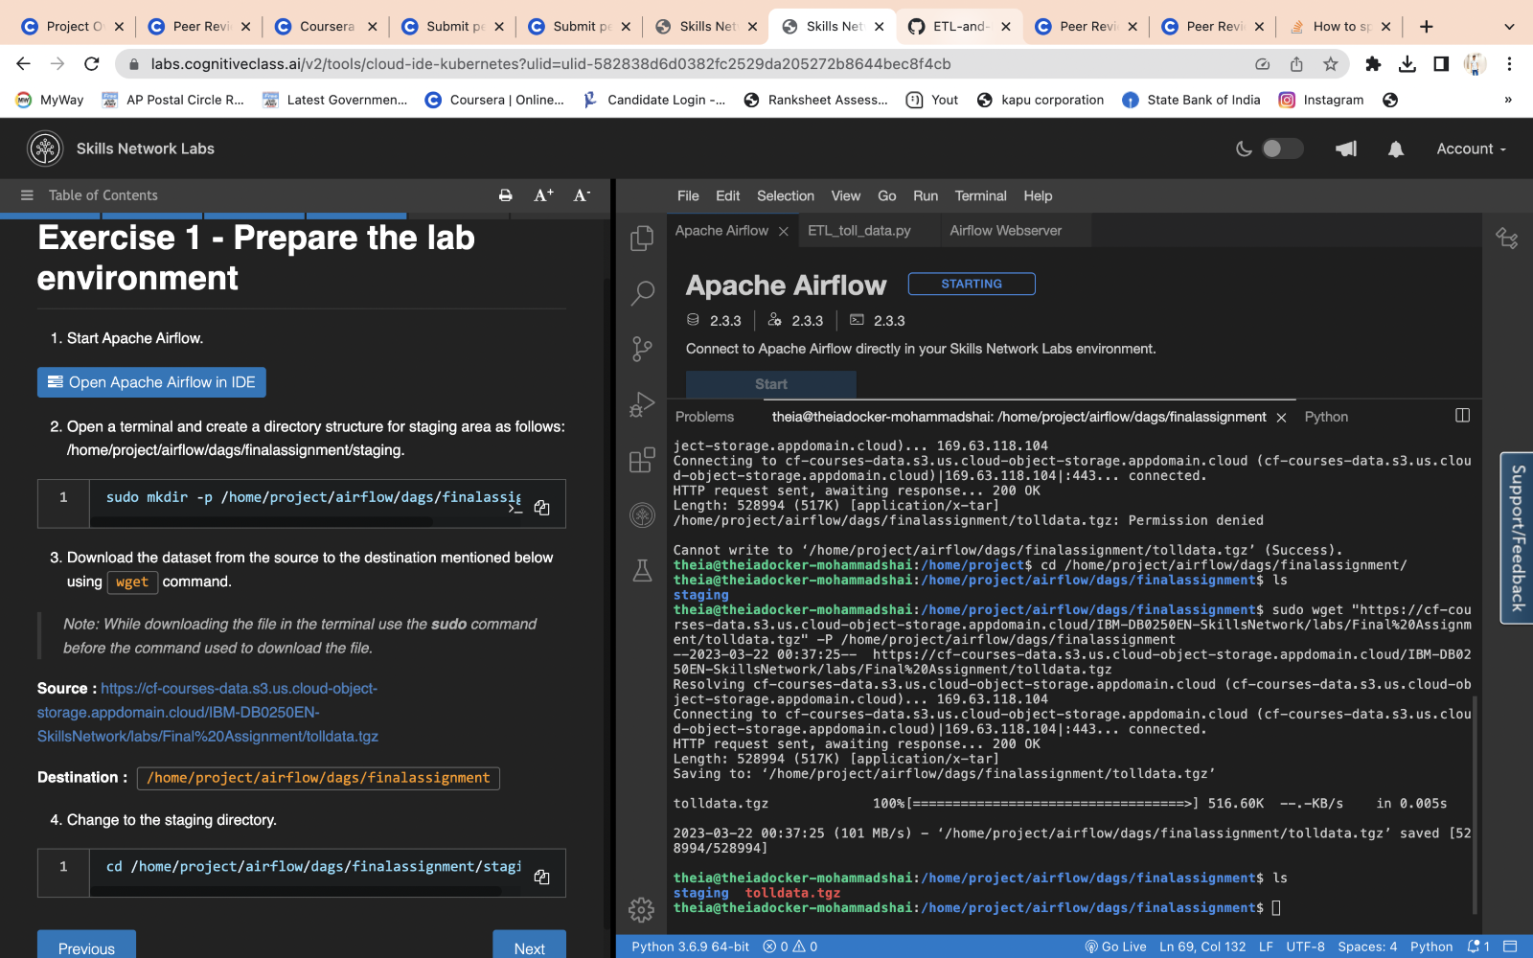

sudo mkdir -p /home/project/airflow/dags/finalassignment/staging

sudo wget "<https://cf-courses-data.s3.us.cloud-object-storage.appdomain.cloud/IBM-DB0250EN-SkillsNetwork/labs/Final%20Assignment/tolldata.tgz>" -P /home/project/airflow/dags/finalassignment

cd /home/project/airflow/dags/finalassignment/staging

Exercise 2 - Create a DAG

ETL_toll_data.py

Exercise 3 - Getting the DAG operational.

Submitting a DAG is as simple as copying the DAG python file into dags folder in the AIRFLOW_HOME directory.

sudo cp ETL_toll_data.py $AIRFLOW_HOME/dags

Run the command below to list out all the existing DAGs.

airflow dags list

If you face issues while submitting the DAG, you can check for errors using the following command in terminal:

airflow dags list-import-errors

Verify that my-first-dag is a part of the output.

airflow dags list|grep " ETL_toll_data "

Run the command below to list out all the tasks in my-first-dag.

airflow tasks list ETL_toll_data